Travel Schedule | 1 | Harbin City Sightseeing (free of charge)  Time: July 16th  In the morning, we will visit Siberian Tiger Park and Sun Island Park.  Lunch  In the afternoon, we will visit the Church of St Sophia(the largest orthodox church in the Far East), Zhongyang Street(the longest walkway in china), Stalin Park , the Memorial Tower of Flood Prevention, Russian Trade Market and Northeast Specialty Store.
Travel Schedule | 2 | Wudalianchi(famous volcano) Tourism  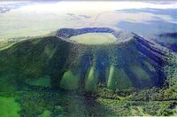  (the fees of this part will be charged directly by the travel agency )
Travel Schedule | 3 | Jingpo Lake Tourism    (the fees of this part will be charged directly by the travel agency)

